Blake Dawson Waldron
SALT
SALT – Setup Guide

Guide to initial install of Salt V3

Custom Business Solutions, IT@BDW
6 July. 04
Issue 0.1
Drafted By | Reviewed By | Approved by
Stephen K-Clark

Contents
Contents 1
RECORD OF ISSUES 1
Background 1
Definitions 1
Before you begin 1
Installing the database 2

RECORD OF ISSUES
Release No | Issue Date | Nature of Amendment
0.1 | 8 July 2004 | Draft 1

TODO: Instructions on how to update salt

Background
SALT v3.0 is a web application written in .NET. This guide provides detailed instruction on setting up the database and website.
By following the instructions in this document an administrator will be able to create the database, website and log in as the salt administrator.

Definitions
Term | Definition
SALT LMS | A standalone application providing the learning management system functions of User Administration, Reporting and Content Management.
- Table 1 – Definitions

Before you begin

Before you begin it is important that you are familiar with this document as it will answer most questions regarding the

Before you begin please ensure that you have to following information and resources.

- Salt is written in .NET. It needs the version 1.1 framework. The .NET framework must be installed on the web-server. If it is not already installed the framework can be downloaded from Microsoft at: http://msdn.microsoft.com/netframework/technologyinfo/redist/ . You can check to see if you already have the .NET Framework installed by clicking Start on your Windows desktop, selecting Control Panel, and then double-clicking the Add or Remove Programs icon. When that window appears, scroll through the list of applications. If you see Microsoft .NET Framework 1.1 listed, the framework is already installed and you do not need to install it again. If you are using Windows Server 2003 the .NET Framework 1.1 is installed by default.

- You will need administrator access to the web server that you are going to install salt onto.

- Salt needs Microsoft SQL Server 2000. It will not run on SQL Server 7.

- You need administrative access to the SQL server to create a new empty database and a public user that has access to the database. You will need to know the connection details to the data base and you will need to know the username and password of the public user. SQL server agent must be running on the database.

- If you want to be able to remotely insert new content (lessons and quizzes) you will need to set permissions on a folder in the salt application to allow folders and files to be FTP’d into it. There is a folder called FTP in the root of the salt website that has been created for this purpose. The other way to load content is to physically copy the content files into this directory where they can be picked up by the application and copied into their proper location within the application.

- Email ??

Installing the database

The salt install package will create all the tables, stored procedures, functions and initial data for the website. This document presumes that you are installing a new instance of salt. Upgrading or reinstalling salt is discussed separately.

Step 1) Create the database
You can either user Enterprise Manager or a SQL script to create the database.
If you do not know how to use Enterprise Manager Instructions are available at http://msdn.microsoft.com/library/default.asp?url=/library/en-us/howtosql/ht_7_design_8oth.asp

Create a database that has an initial size of around 100MB and ensure that it is allowed to grow. The rate at which it grows will be dependant on the number of users and the amount of training that they do. However an initial size of 100-150MB and a growth of 10% is sufficient.

If you wish to use the following script please make sure that you check that the database name, file names and file locations are appropriate for your environment.

USE master
CREATE DATABASE [salt]
ON (
NAME = N'SALT_Data',
FILENAME = N'C:\Program Files\Microsoft SQL Server\MSSQL\Data\SALT_Data.MDF' ,
SIZE = 100,
FILEGROWTH = 10%
)
LOG
ON (
NAME = N'SALT_Log',
FILENAME = N'C:\Program Files\Microsoft SQL Server\MSSQL\Data\SALT_Log.LDF' ,
SIZE = 30,
FILEGROWTH = 10%
)
COLLATE Latin1_General_CI_AS
GO

Step 2) Create a login on the database
After you have created the database use Enterprise Manager to add a new login. The login will be used by the website to access the new, empty database. The login must have public access to the salt database. Please note the user name and password as you will need to enter these in the website on during the install. The script below can be used to create the login.
sp_addlogin
@loginame = 'salt_user'
, @passwd = 'password'
, @defdb = 'salt'

Installing the Website

Step 1) Starting the install
Insert the disk into the web server or copy the contents of the salt install directory onto the web server.
If it does not run automatically run the Setup.Exe file.

Step 2) Is .NET installed ?

If you do not have the .Net v1.1 Framework installed you will get the following error message.

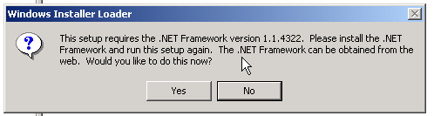

Clicking Yes will forward you to the Microsoft website where you can install the framework. You must install the version 1.1 framework

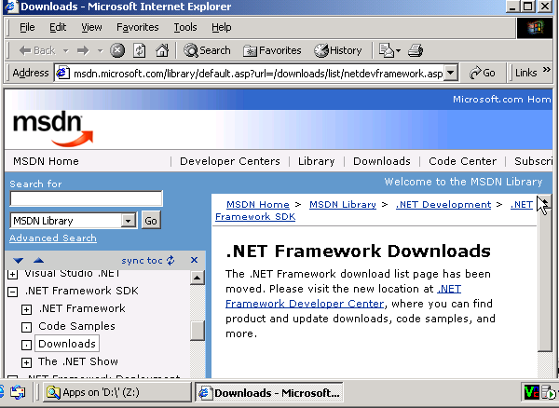

You will not be able to proceed until you have installed the framework.
Details on how to install the .NET framework are provided in Appendix 1.

Step 3) Website Setup Wizard
If you have the framework installed you will see the following screen:

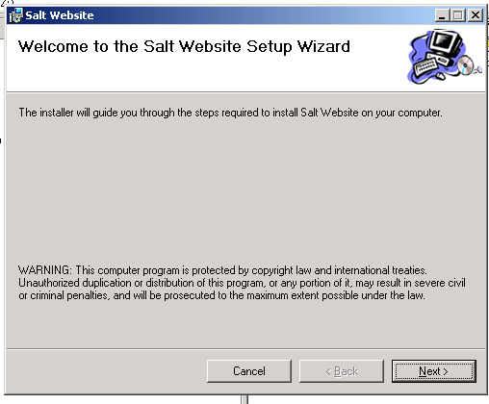
Press [Next] to install

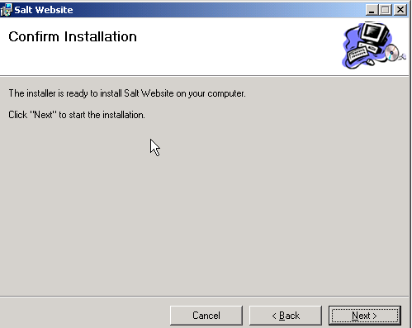

Press [Next] to confirm the installation. The website will now install

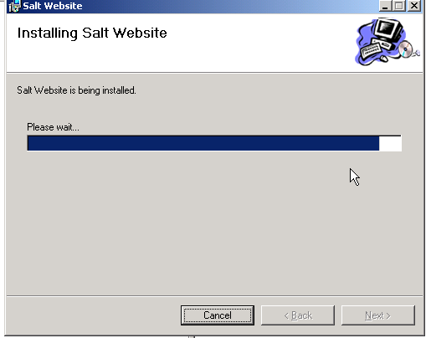

The website needs to know the name of the account under which it will run. The dialogue box suggests the default names for server 2000 and server 2003 instillations. If these have been changed on the server on which you are installing or you have created an account specifically for the website you will need to know the new account name. Salt assumes that it is running under the default account and has only been tested on these accounts. If a server administrator changes these accounts or enforces that salt be run under a different account it is up to the administrator to ensure that salt has sufficient privileges to run. After entering the account name press [Next]

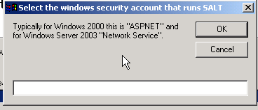

The script will alert you if there is a problem applying permissions to certain files. Pleas note any error messages that do not confirm that permission was granted successfully.
Press [Next].

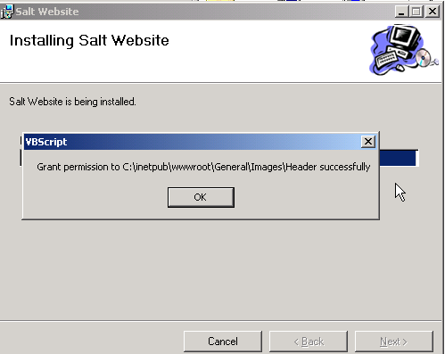

Press [Next].

Step 4) Database Setup Wizard

After installing the web files the database configuration wizard starts.

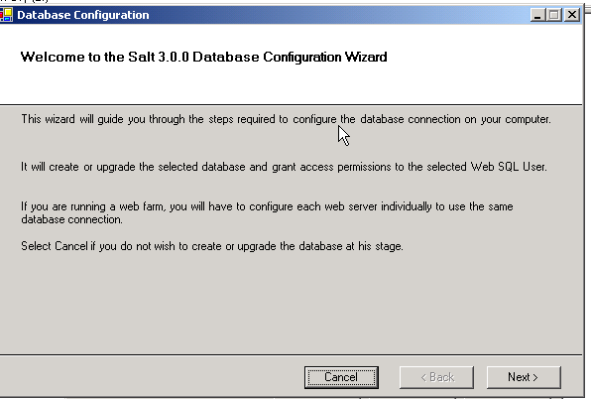

Select the server and database and enter the DBO details for the database. This gives the install process permission to create all the necessary tables and data in the database.
Press [Next].

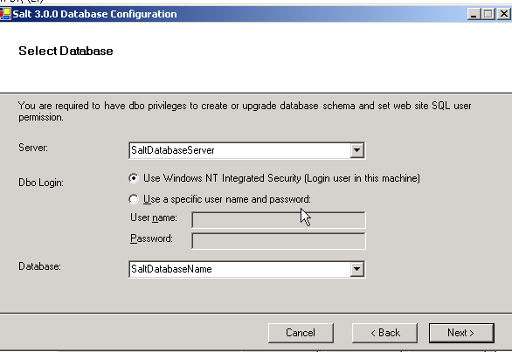

The install scripts will alert you to confirm that the database is empty. This is to ensure that the script does not overwrite an earlier database. If this is a new install press [Yes]
Instructions detailing how to update salt are provided in a separate document.
TODO: write update doc.

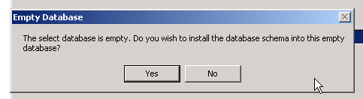

You now need to enter the details for the login (username and password) that you entered in step 2). If you used the script provided in step 2 to create the login without changing it then the username would be ‘salt_user’ and the password would be ‘password’
Press [Next].

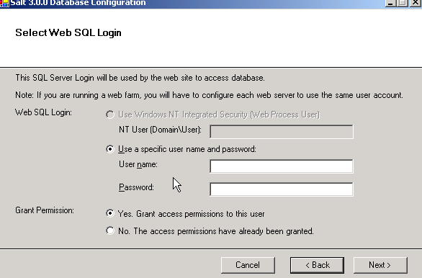

You now need to enter the details for application administrator that you will use to administer the application. You will need to use this administrator after you have created the website and are logging in for the first time. Please ensure that you take a note of the username and password that you create.
Press [Next].

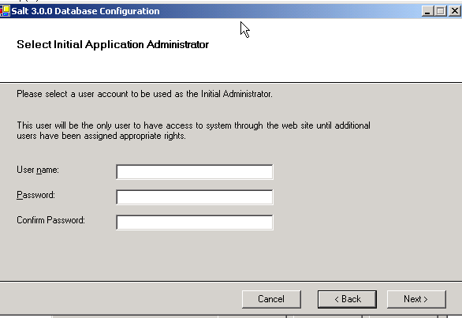

If the details are correct press [Next].

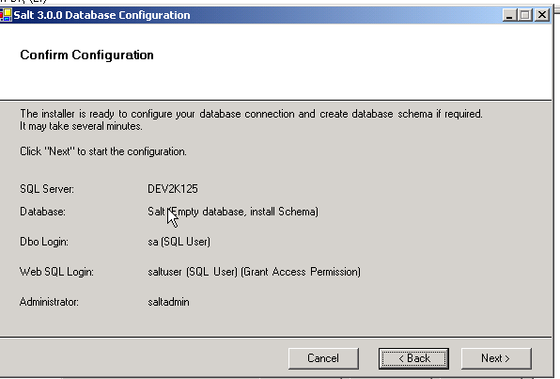

The site will now install. This may take a few minutes.

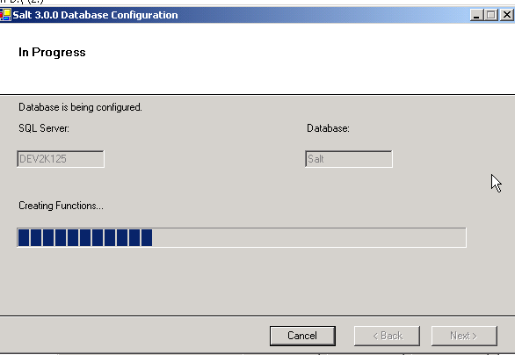

An alert will advise you that you need to ensure that the SQL Server Agent is running. The application creates a job that runs nightly. This will not run unless the SQL Server Agent is running.

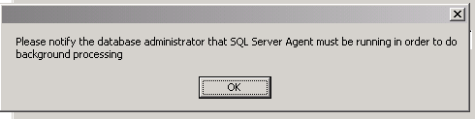

That’s it. You have successfully created the application.
The next step is to log into the website and create your Organisation and Unit details.

Appendix 1
Installing the .NET Framework

